22.45: a) 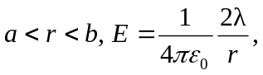 radially outward, as in 22.48 (b).
b) 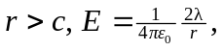 radially outward, since again the charge enclosed is the same as in part (a).

c)
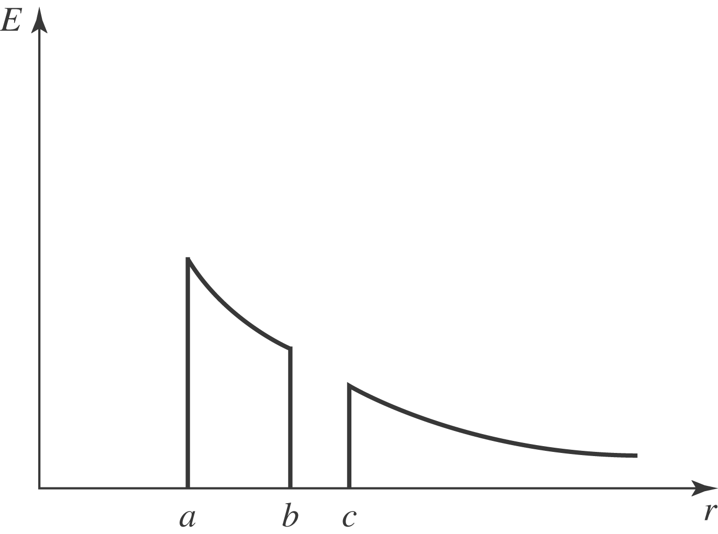
d) The inner and outer surfaces of the outer cylinder must have the same amount of charge on them:

